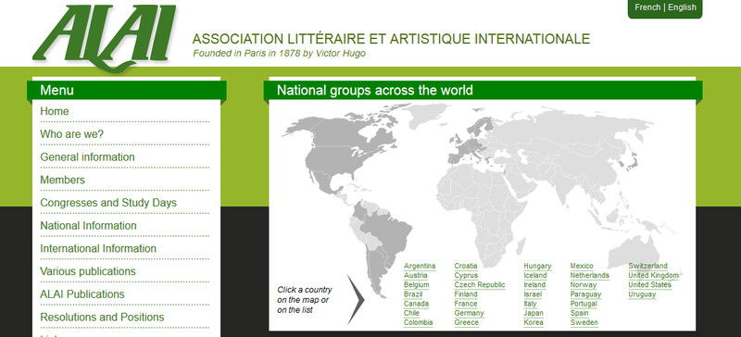

Welcome to the ALAI questionnaire on online practices of author-identification!

The purpose of this questionnaire is to ascertain what author-identification practices are commonly used in ALAI National group countries when works are disseminated online. The results will be used to determine what it means for the name of the author "to appear on the work in the usual manner" (Berne Convention, art. 15) when the work is disseminated over online media.
1. Name and surname of the respondent:
2. E-mail address:
3. Which ALAI National group do you represent?
4. If your responses relate to more countries, please list them here:
Photography and Visual Arts
5. Who are the most prominent photo/visual art sharing platforms or visual content providers in your region? On what other sites (including the authors’ own) do photographs and other works of visual art appear?
6. What practices are employed to place the author’s name in the visual content itself, such as author’s name in a corner of a photograph, mouseover (rollover effect), watermark, metadata in the file’s properties, other means or author-identification, or no attribution at all? Are any of the above means standardized in your media sector?
7. Whatever the means, what information in addition to the name(s) of the author(s) is disclosed? E.g.
A. A copyright symbol?
B. Standard identifier such as an ISBN (equivalent for photos or drawings)
C. Year of first publication? Other year(s) (if so, to what do they pertain)?
D. In addition to the author’s name, does the rightholder’s name (if different from the author’s) appear?
8. Once author-identifying data is included in the digital file, does it remain there, or do third parties, such as platforms, strip it out?
9. What practices are employed to place the author’s name in the description of the visual content on the website (whether the author’s own website or a third-party website) (outside of the content itself, such as below or above a picture, with a hyperlink to external site, with an indication of a public license, where appropriate...)? Are any of the above means standardized in your media sector?10. Whatever the means, what information in addition to the name(s) of the author(s) is disclosed? E.g.
A. A copyright symbol?
B. Standard identifier such as an ISBN (equivalent for photos or drawings)
C. Year of first publication? Other year(s) (if so, to what do they pertain)?
D. In addition to the author’s name, does the rightholder’s name (if different from the author’s) appear?

11. How do the service/platform providers named above in question 5 identify the author and in which form (questions 6-10)?
Music, Audiobooks, Radio
12. Who are the most prominent online radio broadcasters, on demand music services (both for streaming and downloading) or other similar services or platforms offering audio content, including audiobooks, podcasts etc. in your region?
13. Is there a practice to mention the author’s or rightholder’s name within the audio content itself? This may differ for radio, podcasts or audiobooks (where it is common to mention an author) and for musical services where the name may appear in the file’s metadata or with the mouseover (rollover) effect. Are any of the above means standardized in your media sector?
14. If the means of author-identification involve information that can be visualized (as opposed to a purely audio attribution of authorship), what information in addition to the name(s) of the author(s) is disclosed? E.g.
A. A copyright symbol?
B. Standard identifier such as ISRC
C. Year of first publication? Other year(s) (if so, to what do they pertain)?
D. In addition to the author’s name, does the rightholder’s name (if different from the author’s) appear?
15. Once author-identifying data is included in the digital file, does it remain there, or do third parties, such as platforms, strip it out?
16. What practices are employed to place the author’s or rightholder’s name in the description of the audio content on the website (outside of the content itself, such as below or above a file, with a hyperlink to external site...)? Are any of the above means standardized in your media sector?
17. Whatever the means, what information in addition to the name(s) of the author(s) is disclosed? E.g.
A. A copyright symbol?
B. Standard identifier such as ISRC
C. Year of first publication? Other year(s) (if so, to what do they pertain)?
D. In addition to the author’s name, does the rightholder’s name (if different from the author’s) appear?

18. How do the service/platform providers named above in question 10 identify the author and in which form (questions 13-17)?
Film, TV, Video
19. Who are the most prominent online TV broadcasters, user generated video sharing platforms, on demand film providers (both streaming and downloading) or other similar services or platforms offering audiovisual content in your region?
20. What means are employed to place the author’s or rightholder’s name in the audiovisual content itself, such as in the opening or closing credits, on the bottom of the window with the film, by a watermark placed over the film, metadata in the file’s properties, use of the mouseover (rollover) effect etc.? Are any of the above means standardized in your media sector?
21. Whatever the means, what information in addition to the name(s) of the author(s) is disclosed? E.g.
A. A copyright symbol?
B. Standard identifier such as ISRC (music videos) or other equivalent
C. Year of first publication? Other year(s) (if so, to what do they pertain)?
D. In addition to the author’s name, does the rightholder’s name (if different from the author’s) appear?
22. Once author-identifying data is included in the digital file, does it remain there, or do third parties, such as platforms, strip it out?
23. What means are employed to place the author’s or rightholder’s name in the description of the audiovisual content on the website (outside of the content itself, such as below or above a file, with a hyperlink to external site...)? Are any of the above means standardized in your media sector?
24. Whatever the means, what information in addition to the name(s) of the author(s) is disclosed? E.g.
A. A copyright symbol?
B. Standard identifier such as ISRC (for music videos) or other equivalent
C. Year of first publication? Other year(s) (if so, to what do they pertain)?
D. In addition to the author’s name, does the rightholder’s name (if different from the author’s) appear?

25. How do the service/platform providers named above in question 15 identify the author/rightholder and in which form (questions 20-24)?
E-zines, E-books, Blogs, News, News Aggregators
26. What are the most prominent providers of online literary content (e.g. magazines/e-zines, e-books, blogs, news, including news aggregators) in your region and how do they identify the author or rightholder?
27. Is there a practice to mention the author’s or rightholder’s name within the literary content itself, such as author’s name as a byline appearing together with the literary content, or disclosed via mouseover (rollover effect), watermark, metadata in the file’s properties, other means or author-identification, or no attribution at all? Are any of the above means standardized in your media sector?
28. Whatever the means, what information in addition to the name(s) of the author(s) is disclosed? E.g.
A. A copyright symbol?
B. Standard identifier such as an ISBN or ISSN.
C. Year of first publication? Other year(s) (if so, to what do they pertain)?
D. In addition to the author’s name, does the rightholder’s name (if different from the author’s) appear?
29. Once author-identifying data is included in the digital file, does it remain there, or do third parties, such as platforms, strip it out?

30. What practices are employed to place the author’s or rightholder’s name in the description of the literary content on the website (outside of the content itself, such as below or above a file, with a hyperlink to external site...)? Are any of the above means standardized in your media sector?
31. Whatever the means, what information in addition to the name(s) of the author(s) is disclosed? E.g.
A. A copyright symbol?
B. Standard identifier such as an ISBN or ISSN.
C. Year of first publication? Other year(s) (if so, to what do they pertain)?
D. In addition to the author’s name, does the rightholder’s name (if different from the author’s) appear?

Websites as Such
32. Is there a standardized or prevailing practice how to place the name of the author in and to the website as such, e.g. at the very bottom of the website, at the bottom of the window (if the page is scrolled or the window resized, the text sticks to the lower window border, elsewhere than at the bottom of the website), with a hyperlink to external site naming the actual rightholder?.
33. Whatever the means, what information in addition to the name(s) of the author(s) is disclosed? E.g.
A. A copyright symbol?
B. Standard identifier such as an ISBN .
C. Year of first publication? Other year(s) (if so, to what do they pertain)?
D. In addition to the author’s name, does the rightholder’s name (if different from the author’s) appear?

General
34. Can you identify substantial similarities or differences between the online and offline identification practices in your region?

35. Are you aware of any case law concerning the legal protection of electronic rights management information (article 7 of Directive 2001/29 / article 12 of the WCT) in your country?

